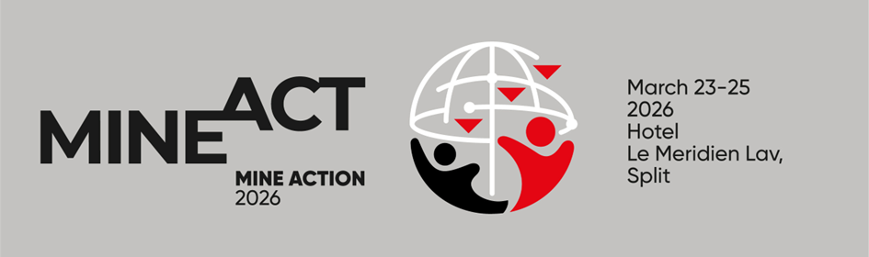

Dear colleagues,
The 22nd International Symposium “Mine Action 2026” will be held from 23rd to 25th March 2026 in Le Meridien Lav Hotel in Split. The Symposium is organized by the Croatian Mine Action Centre – Centre for Testing, Development and Training, and the Croatian Ministry of the Interior.
The participation of manufacturers of mine-action equipment rounds out the picture of current progress in the field and offers a valuable chance for them to engage with mine-action stakeholders from around the world.
We invite you to showcase your equipment by reserving an exhibition booth at the hotel and promoting your company in the Book of Papers.

CONTACT PERSON:
Sanja Vakula
Phone: +385 91 650 00 22
e-mail: sanja.vakula@ctro.hr

For more information, please visit www.ctro.hr

Sincerely yours,

Katarina Markt

Director

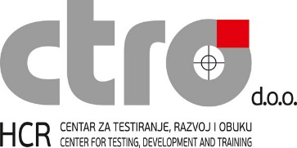

  - PRICE LIST*

All participants – 330 EUR
Equipment exhibitors are exempt from paying the registration fee for two representatives.
Presenters: first authors 100 EUR, co-authors 330 EUR
Accompanying persons – 100 EUR

VISAS:
Visa requirements overview is available at the website of the Ministry of Foreign Affairs: http://www.mvep.hr/en/

Exhibition booth | 2.600 EUR  (registration fee for 2 persons included)
ADVERTISING IN THE BOOK OF PAPERS (full page)
Back cover | 1.700 EUR
Inside front or back cover | 1.500 EUR
First or last page of the book block | 1.300 EUR
Inside page | 950 EUR
*prices are expressed without VAT. If the Client is not liable for VAT in their country and does not have a valid VAT number, 25% VAT will be charged on the stated prices.

Due date for registering for equipment exhibition: 1st March 2026

Contact person:
Sanja Vakula, HCR-CTRO d.o.o.; e-mail: sanja.vakula@ctro.hr

EXHIBITION AND ADVERTISING ORDER

Company name
VAT number
Contact person
Address
Postal code & City
Country
Phone number
E-mail
Exhibition booth | YES NO  Equipment type:
Advertising | YES NO  Advertisement type:
Date, signature and stamp

